Working Well Together in Ministry:
Addressing Issues of Bullying and Harassment

Contents
- Introduction
- Statements of Commitment and Principle
- Definitions
- Examples of Bullying Behaviour and Harassment
- Spiritual Abuse
- Supporters and other support
- Confidentiality
- Fair procedures
- False accusations
- Working Together
Annex A - I think I have been the target of bullying or harassment, what can I do?
Annex B - I have been accused of bullying or harassment, what can I do?
- Introduction

Ministry in the Church by its very nature will usually involve working with other people. The Gospels show us that Jesus was constantly interacting with the people around him, working with and through his disciples, ministering to groups of people large and small as well as individuals, and teaching and challenging those whom he met. Occasionally he withdrew to a private place to be alone with the Father, but most of the time his ministry brought him into contact with other people and the ministry of those in the Church today will do the same.

It is, of course, the hope of all of us that contacts with others will be helpful and lifegiving. Often this is the case, but there are also occasions when our contacts with others may not reach this high standard.
“Good personal relationships are a significant form of witness to the gospel. As we are called to honour God so we reflect our honouring of Him in our honouring of other human beings. We believe that all forms of abuse, harassment and bullying are intolerable in the Christian Church.

Within the life of the church there will be times of disagreement and difference and this can be a sign of health and life as much as a sign of weakness.

We are all unique individuals in the eyes of God and our personality, life experience, and our discipleship invites us to honour and celebrate that difference. How we then conduct our relationships within the Christian community can assist the attraction to Christian discipleship or it can discourage. It is important for church members to recognise that many people who enquire or want to explore discipleship arrive at our churches with high expectations of the nature of the relationships they will encounter. Sadly sometimes they leave disillusioned.”
Taken from Diocese of Chester policy: Dignity at Work and in Church Life

This policy is about situations of bullying and harassment. It will not and cannot cover or be able to resolve all situations of conflict, many of which do not slip over into these specific forms of behaviour. It does, however, provide a framework for dealing with situations where because of conflict or other causes there has been serious and damaging behaviour which has been experienced as bullying or harassment.

This policy is the Diocese of Leicester policy for those in ordained ministry or who minister with the Bishop’s licence, permission or other authorization. It applies where they are either the alleged perpetrator or the presenting victim of bullying or harassment.

Situations within churches where neither the alleged perpetrator nor the presenting victim is in ordained ministry nor ministering with the Bishop’s licence, permission or other authorization do not fall within the scope of this policy. This is because such situations are best resolved at local level and to this end PCCs are therefore encouraged to consider adopting their own policy to cover situations of bullying and harassment.

- Statements of Commitment and Principle

The Church is required by God to foster relationships of the utmost integrity, truthfulness and trustworthiness. Abuse, harassment and bullying – however rare – will not be tolerated in the Diocese. All complaints of abuse, harassment and bullying will be taken seriously and thoroughly investigated.

+John, Acting Bishop of Leicester
28 November 2015

The clergy and laity of this diocese, in approving this policy, recognise the importance of good relationships in their church life and discipleship, and that poor behaviour can set back the mission of the church. They undertake to challenge poor behaviour, seek help when this does not stop and participate in any mediation or investigation, or use the appropriate procedure to end the problem.

The Bishop, their staff, and those who share episcope recognise the importance of being good role models in the way that they interact with those for whom they have pastoral care and/or managerial oversight. A culture of support and empowerment where there is consultation and real discussion of problems and their solutions is one which should discourage bullying and harassment. They recognise that training in this area is important and commit themselves to this.

Definitions

What is bullying and harassment?

Bullying and harassment is any behaviour that could potentially undermine someone’s dignity and respect and should be regarded as unacceptable. If it is not challenged it is likely to escalate and lead to significant difficulties for all concerned.
In establishing the links between ‘unacceptable behaviour’, ‘bullying’ and ‘harassment’ as well as drawing together the common themes and issues the following broader definition may be helpful:

“Any behaviour, always involving a misuse of power, which an individual or group knows, or ought reasonably to know, could have the potential effect of offending, humiliating, intimidating or isolating an individual or group should be regarded as unacceptable in the workplace.

‘Unacceptable behaviour’ changes its label to ‘bullying’ or ‘harassing behaviour’ when it causes actual harm or distress to the target(s), normally but not exclusively, after a series of incidents over a prolonged period of time.

Lack of intent does not diminish, excuse or negate the impact on the target or the distress caused. The degree of intent is only relevant in terms of how the behaviour should be challenged and the issues subsequently resolved.”
Fergus Roseburgh, Senior Staff Representative, Unite the Union, The Children’s Society. March 2007

How can bullying and harassment be recognised?

Bullying may manifest itself in a variety of different ways. It is usually persistent, and often unpredictable, and can amount to severe psychological intimidation. It is insidious, and undermines the ability and confidence of the person suffering under it.

Definition of bullying in the course of ministry

Bullying in the course of ministry is repeated inappropriate, offensive behaviour, which is often an abuse of power or position. It can be direct or indirect, either verbal, physical or otherwise, conducted by one or more persons against another or others, at the place of work and/or in the course of an office holder or person in authorized ministry carrying out their duties, which could reasonably be regarded as undermining the individual’s right to dignity at work and/or in undertaking their role. It can lead to fear, isolation, de-motivation and reduced output, poor concentration, symptoms of stress, a noticeable level of sickness absence or stubborn attendance when obviously unwell, psychological, emotional and physical harm. In some serious cases one incident alone can constitute bullying.

Definition of Harassment

Harassment, in general terms, is unwanted conduct affecting the dignity of men and women in the workplace or in the course of conducting ministry. It may be related to age, gender, sexual orientation, race, disability, religious belief (including theology or churchmanship), nationality or any personal characteristic of the individual, and may be persistent or an isolated incident. The important point is that the actions or comments are viewed as demeaning and unacceptable to the recipient.

- Examples of Bullying Behaviour and Harassment

Lists of examples are helpful because they aid us in understanding what behaviour is and is not acceptable. Lists are never exhaustive because it is impossible to cover every conceivable situation. There is also, inevitably, a degree of overlap between bullying and harassment and some forms of behaviour may appear to fit under either category. In a policy like this it is necessary to focus on definitions of negative behaviour, but the lists can also remind us of the good forms of behaviour that build people up and encourage healthy and positive relationships.

It should also be noted that many people in ministry will not have a line manager relationship like those in secular employment. Pressure of work may, therefore, be self-generated or generated by the expectations of a congregation rather than the demands of a superior or any one individual. In such cases pressure may be destructive without being caused by behaviour that constitutes bullying or harassment. The Diocese will always want to support priests who are working with their congregation(s) to define a role that is manageable and not harmful, and this may, in some situations, help to reduce the likelihood of bullying or harassment taking place. The Diocese will also want to help those in ordained or licensed ministry both to be resilient and to have reasonable expectations of themselves.

Examples of bullying behaviour

This list of behaviours is not exhaustive but gives a clear indication of the sorts of actions that constitute bullying:
- removing areas of responsibility without discussion or notice
- isolating someone, deliberately ignoring or excluding them from activities
- consistently attacking someone’s professional, personal or spiritual standing
- setting out to make someone appear incompetent or unsuitable for ministry
- persistently picking on someone in front of others
- deliberate sabotage of work or actions
- deliberately withholding information or providing incorrect information
- deliberately holding meetings when somebody is unable to attend
- overloading with work/reducing deadlines without paying attention to any protest
- displays of offensive material
- use of e-mails and/or social media to reprimand, insult or otherwise inform someone of their apparent failing, either to the individual or to third parties
- repeatedly shouting or swearing in public or in private
- spreading malicious rumours to third parties
- public humiliation by constant innuendo, belittling and ‘putting down’
- personal insults and name-calling
- aggressive gestures, verbal threats and intimidation
- persistent threats about security
- making false accusations
- aggressive bodily posture or physical contact
- talking/shouting directly into someone’s face
- direct physical intimidation, violence or assault

The most serious incidents might result in:
- creating an unsafe working environment
- ignoring signs of overwork and extreme stress
- putting someone’s health physically, emotionally or psychologically at risk by making them upset, frightened and/or ridiculed

Distinguishing between bullying and reasonable behaviour

On the other hand it is important to distinguish between bullying, and behaviour that is reasonable in a particular context. For example there may be occasions where shortcomings in performance are being addressed and more incisive behaviour is interpreted as bullying simply because the recipient is unused to being challenged or asked to account for their actions.

Examples of harassment

The following, though not an exhaustive list, may constitute harassment:
- Physical contact ranging from touching to serious assault.
- Verbal and written harassment through jokes, offensive language, gossip and slander, letters.
- Isolation or non-cooperation at work, exclusion from social activities.
- Intrusion by pestering, spying, following etc.
- Repeated refusal to recognize appropriate boundaries (eg days off).
- Repeatedly calling/sending texts at inappropriate times.

In this context it is important to note that those involved in ministries which are licensed or authorised by the Bishop may often work unusual hours. They may expect to receive urgent calls at any time of day or night, but have a right to expect that non-urgent business will be reserved for regular work times.

- Spiritual Abuse

All those in positions of spiritual leadership need to be aware of the potential for spiritual abuse of those in their care. Spiritual abuse may involve the use of scripture, church tradition or an appeal to the authority of one’s position in order to exert control over others.

Definition of Spiritual Abuse

“Spiritual abuse is coercion and control of one individual by another in a spiritual context. The target experiences spiritual abuse as a deeply emotional personal attack.

“This abuse may include:- manipulation and exploitation, enforced accountability, censorship of decision making, requirements for secrecy and silence, pressure to conform, misuse of scripture or the pulpit to control behaviour, requirement of obedience to the abuser, the suggestion that the abuser has a “divine” position, isolation from others, especially those external to the abusive context.”
(Oakley & Kinmond, 2013 p21)

Spiritual abuse is also covered in the Church of England’s Policy for Safeguarding Adults (Promoting a Safe Church, 2006 p39).

- Supporters and other support

This diocese is committed to the encouragement and training of Supporters. Supporters
- are concerned members of the clergy and laity who have volunteered and been accepted to undertake these duties.
- have received special training for this role and have the full support of the Bishop.
- are available to anyone in a clergy or lay ministry role which is licensed or authorised by the Bishop to offer, in confidence, advice and information as required.
- are also able to channel complaints.
- will not normally get involved in negotiating or mediating between the parties concerned.
- will listen in an informal atmosphere and will allow the person in receipt of their support to decide what action to take and what support may be needed.

Other forms of support are available and may include counselling, support from the Area Dean, and some financial support for a retreat. Members of a trade union may also be able to call on union resources for support. Clergy who are office holders under Common Tenure are also covered by a Grievance procedure, Ministerial Development Review, and a Capability procedure. Whilst these may not appear to be forms of support, they do contribute to an atmosphere in which difficult situations can be aired and resolution sought.

- Confidentiality

These matters are to be treated with absolute confidentiality and no action will be taken without the willing consent of the person who feels he or she has been a target, except where there are circumstances which demand referral to the statutory authorities (eg child protection issues).

- Fair procedures

The Diocese is committed to supporting those in ordained ministry or who minister with the Bishop’s licence, permission or other authorization who are experiencing bullying, harassment or spiritual abuse and the procedures to be followed are set out in the following paragraphs.

When the alleged perpetrator and the presenting victim are both in licensed ministries complaints of bullying or harassment may, with the presenting victim’s consent, be brought under the Grievance Procedure for Licensed Ministers. When the alleged perpetrator is a clergy person it may be more appropriate for the presenting victim to make a complaint under the Clergy Disciplinary Measure 2003 or an archdeacon could do this with the presenting victim’s consent.
When the alleged perpetrator is in a lay ministry, complaints of bullying and harassment may, with the presenting victim’s consent, be dealt with in one of a number of ways according to the circumstances, eg the use of the Mediation Service, referral to the Counselling Service, meeting with the Archdeacon to hear both sides of the allegations.

On the whole it is safest to take the view that if a person complains that they are being bullied or harassed, then they have a grievance, which should be dealt with regardless of whether or not their complaint accords with a standard definition.

The first stage of the procedure will usually involve informal measures to resolve the situation. If these informal measures fail to bring about a resolution of the situation within 6 months then the formal stage of the process should be used. In serious cases it is possible to move directly to the formal stage.

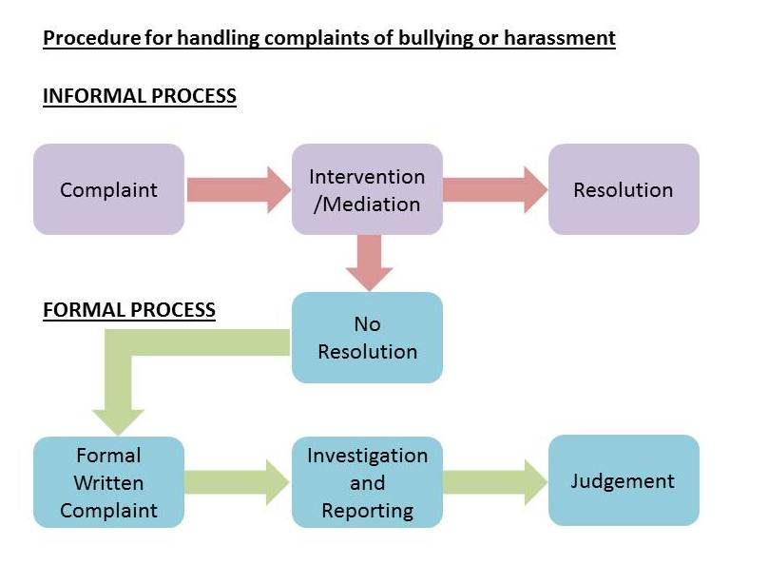

- False accusations

Just as complaints and concerns about bullying and harassment are treated seriously, so false accusations are a serious matter where they are made knowingly. The behaviour of anyone who is found to have made an unfounded, deliberately malicious complaint or allegation will be regarded with the utmost seriousness and where possible formal action taken. In the case of a clergy person this may be a complaint under the Clergy Disciplinary Measure 2003. A member of either the clergy or laity could be subject to an action for defamation if they have deliberately made false accusations against someone else.

- Working Together

This policy deals, inevitably, with difficult situations and a painful subject. The other side of this coin is that in most situations of ministry relationships are very good and people work well together, understanding their differences and working through these for the sake of the ministry in which they are involved. The aim of this policy is not, ultimately, to punish those who transgress, but to encourage good relationships across the board. The ability to work through situations of conflict in honesty and vulnerability can be a powerful witness to the Gospel. Jesus calls on us to love one another as he loves us. If we can seek always to be gentle, even with those who do not agree with us, then it will be easier to avoid situations where bullying and harassment occur, or are felt to have occurred.
Annex A
I think I have been the target of bullying or harassment, what can I do?

If you are experiencing bullying or harassment you should not suffer in silence or feel that you are to blame in some way for inviting the behaviour.

What to do if you are experiencing bullying

- If possible, clarify your role description to check that your responsibilities match it.

- Keep a factual log of all incidents of bullying: dates, times, nature of incident, details of accusations, criticisms, emails, text messages and any other correspondence. This may be needed as evidence should harassment, victimisation or bullying continue or subsequently recur.

- Make a note of any people who have observed bullying incidents.

- Try to avoid situations where you are alone with the perpetrator

- Use the available informal and formal options open to you. You can seek advice and support and advice from the following: colleagues, members of the clergy, Archdeacon, counselling, trades union representatives, mediation service,Supporters. Supporters are volunteers who are fully trained and will work with you in confidence to advise on procedures for dealing with bullying and harassment and to clarify the impact of the behaviour you are experiencing so that you can decide what you want to do about it.

Informal Action

- Try to resolve the complaint informally at first by explaining directly to the perpetrator the effect their behaviour is having and that you want it to stop. The informal route may result in the perpetrator stopping their behaviour and so prevent the matter becoming public, or escalating. You can also consult a supporter and discuss with them whether to confront the alleged perpetrator, alone or with a supporter or whether you would like somebody to talk to the alleged perpetrator on your behalf.

- Every effort should be made to use informal means, including considering mediation before formal procedures are invoked. But if the behaviour continues, make it clear that you will make a formal complaint. This may be enough to resolve the matter, particularly if the person was unaware their behaviour was causing offence.

- Whenever possible, any complaint of bullying or harassment should be notified in confidence to the appropriate person, in accordance with the flowchart set out below.

Formal action

- Where clergy are involved and it is decided by the area dean or archdeacon that the matter is sufficiently serious or constitutes gross misconduct, they will make a file note of action taken and with your permission, institute an investigation under the formal procedures.

- Formal procedures are not dependent on you having to take personal action to ask the perpetrator to stop their behaviour. It is recognised that by its very nature bullying is something that may happen over a prolonged period of time and the longer it goes on the more difficult it is to take personal action to confront the behaviour.

- If the perpetrator is a clergy person or licensed lay worker and an informal approach has either failed to help resolve the matter, or has not been possible for any reason, it may be appropriate to use the Grievance Procedure for Licensed Ministers or, in the case of clergy, the Clergy Discipline Measure, 2003.

REMEMBER – The earlier action is taken the better for all concerned.

Who to inform
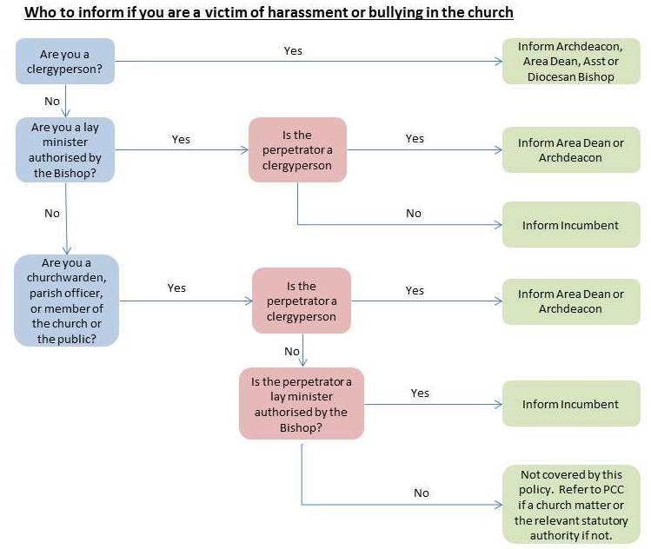
Annex B
I have been accused of bullying or harassment, what can I do?

- Bullying and harassment are matters that must be taken seriously. An accusation does not necessarily signify a judgement that you are guilty and there will need to be a discussion with you in order to establish the true nature of the situation. It is possible there might be a problem that has arisen because you have not realised the effect of your actions or you may not have intended the effects complained of.

- The perception of the person complaining of bullying or harassment is, however, an important factor in determining whether or not harassment has taken place. Simply to deny there is a problem or to suggest that the problem lies with the person making the complaint is not normally sufficient.

- If you are a member of the clergy and accused of harassment, you are encouraged to contact your area dean, archdeacon, or the assistant or diocesan bishop. Lay members of the church should approach their parish priest in the first instance if appropriate. The aim of the person you contact will be to facilitate discussion with a view to resolving the problem at source, if possible.

- You are strongly advised to contact one of the Diocesan Supporters who are available to offer support in cases of bullying and harassment. Supporters are fully trained, guarantee confidentiality and will meet with you in private to talk through your position. They will advise you on procedures for dealing with claims of bullying and harassment and help you to clarify the impact your behaviour may be having so that you can decide on your course of action.

- Every effort will be made to resolve the problem quickly through informal discussion. You will be asked to reflect on your behaviour and the possibility that you might be at fault, whether consciously or not. You may find it helpful to keep a log of your interactions with the person who feels bullied or harassed and to seek to have other people around when you meet him or her.

- The diocese will ensure that any formal procedures are fairly and properly followed. Details relating to the circumstances that gave rise to the complaint, the evidence of witnesses and the nature of the professional relationship between the person making the complaint and yourself will all be taken into account.

- If you are a clergy person or licensed lay minister accused of bullying another minister, a formal complaint may be made under the Grievance Procedure for Licensed Ministers. If you are a clergy person accused of bullying other clergy or laity there will be consideration of whether the matter constitutes misconduct under the Clergy Discipline Measure 2003.

- If you are a lay person accused of bullying a person in a lay ministry which is licensed or authorized by the bishop this will be dealt with in different ways depending upon your position, which could involve mediation, counselling support and/or a meeting with the archdeacon to hear both sides of the situation.

- As a result of informal and formal action you may be offered help to recognise, understand and modify your behaviour; and you are strongly advised to accept this help.

- Throughout any informal or formal procedures the principal objective is to identify the underlying issues and eliminate the cause of the offence as quickly as possible and with minimal recrimination.

Who to inform
