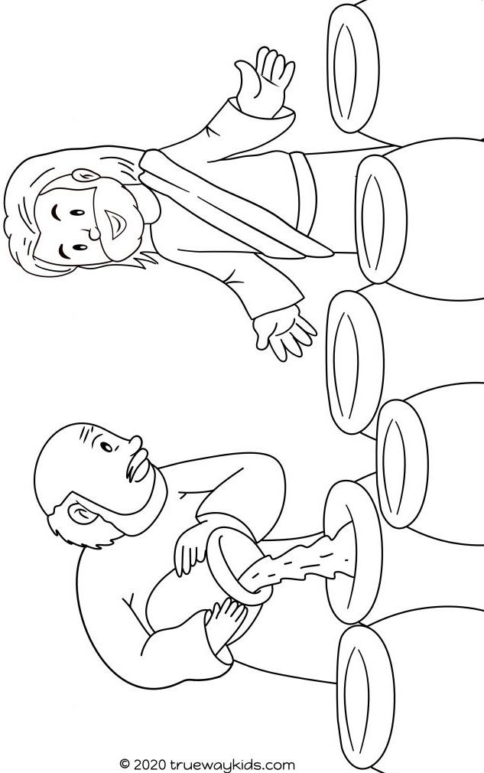
From the bible John 2:1-12 Jesus said, ‘Fill the jars with water.’ They filled the jars with water. The host of the wedding tasted it. It was wine, Jesus turned water into wine!

