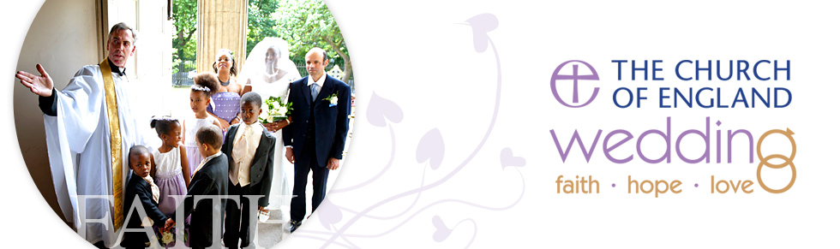
Getting married at St Mary’s

Congratulations on your forthcoming marriage in church. A church wedding will add a spiritual dimension to your marriage that is blessed by God. Christians believe that marriage is a gift from God. In the marriage ceremony a couple makes a public declaration of lifelong commitment to love each other. A commitment, by its nature, is a challenge, but there’s plenty of evidence to show married couples are more likely to be healthy, wealthy and wise.

God intended marriage to offer the right place to grow in love and support for each other, and provide a stable and secure environment for bringing up children. Marriage can change us for the better, and as we change, our marriage grows along with us.

The church will be praying that as you prepare for your wedding day your relationship will not only develop with each other, but also your faith in God will also deepen. Married life needs the power of Christ to sustain and strengthen it. Therefore it’s of great benefit if couples include in their preparations coming to church services when they are able, to nurture the faith they have and to prepare them for the responsibilities of married life.

Please keep this booklet in a safe place for easy reference and do make contact should you require any further information. We look forward to supporting you through this process.

These guidelines are designed to ensure that we can help you to have everything in order to proceed with the marriage and to ensure the marriage complies with both UK Civil and Church law

Completing the Application Form
Please complete the form carefully. The information will be used to produce your legal marriage certificate which is a direct copy of the marriage registers. Therefore if any of the information given changes, you must inform us at least 1 week before the wedding day to ensure that your marriage is legal. The registers cannot be amended once they are completed. If you have any questions relating to the form please contact the church office on 01455 558797.

For the purposes of the Data Protection Act 1998 the information on the form will be used to ensure that the legal requirements relating to the marriage are complied with and to make arrangements for the wedding ceremony. The Minister will only share the information with those who need to see it for those purposes. Non-UK applicants should be aware that information may be referred to the UK Border Agency for verification.

Date and Time
Most weddings take place on a Saturday, but to be legal they must take place between 8.00am and 6.00pm on any day, however we do not carry out weddings on a Sunday. We will do our best to fit in with your wishes, but please do not book anything further until the time and date of your wedding has been agreed with us. Further notice may be required in circumstances that require a marriage licence to be applied for.

Officiant
The Lead Minister (Rector) normally performs the marriage ceremony but another minister will cover for holidays, sickness, parish vacancy and where the Rector needs to be available for other duties. These circumstances may determine a change as to who takes the service.

Marriage in church after divorce
There are special guidelines on marriage in the church if you are divorced. There may well be a way forward so please do speak to us if you require guidance.

Banns
Banns are an announcement in church of your intention to marry and a chance for anyone to put forward a reason why the marriage may not lawfully take place. Banns need to be read in the parish where each of you lives, as well as the parish church in which you are to be married, if that is somewhere else. You must have your banns read out in church on three Sundays during the three months before the wedding. It is the responsibility of the partner who lives outside the wedding parish to arrange the calling of the banns by their local Church of England minister. You must then forward the Banns Certificate from that minister to us. The wedding cannot proceed without the certificate.

There are some circumstances in which you may need a special licence to get married and we can advise you if this is the case.

Wedding Fees
The fees are listed below for 2016. These are set by the Church of England and may increase each year. The local charges for the organist, bells, choir and verger also change from time to time.

Please enclose your banns fee with the completed application form; this fee acts as a non returnable deposit.

Publication of Banns £27.00
Marriage Service £415.00
Marriage Certificate £4.00
Verger £20.00
Organist £70.00
Choir £50.00 (Lutterworth Church Only)
Bells-Bitteswell church £120.00
Bells-Lutterworth church £150.00

The fees are payable by instalments or one month before the wedding to the Church Office. Please make any cheques payable to ‘St Mary’s Lutterworth PCC’.

lutterworth & district Choral Society
In addition to the concert programme our society has we are able to sing a selection of songs or anthems during the signing of the register and leading the congregational singing. We normally have 20 plus choristers available and our current fee is £150. Contact Lorna on 01455 282312 or lorna.thompson@talktalk.net

Rehearsal
A rehearsal is arranged a day or two before the wedding to enable you to have a ‘practice run’ through the ceremony itself, so that on your wedding day you will be familiar with the order in which things happen. This will hopefully help you to feel more relaxed on your wedding day.

Photography, Videos and Copyright
Photographs can be taken before and after the service and also during the signing of the registers. Video camcordists are restricted to a location at the side of the church. The church’s copyright licence only covers worship hymns and songs during the service. Increasingly, however, other music is being sung or played and also we do not know what may be added or overdubbed to video recordings later. A company called PRS for Music offer a LM Licence (Limited Manufactured Licence) for weddings. Please visit www.prsformusic.com for further information. You will need to present us with a copy of this licence at the wedding rehearsal or earlier if you prefer. Unfortunately without a licence we will not be able to allow the use of video recording equipment during the service, either by a professional or guests.

Flowers
If you intend to have flowers in church for your wedding, either arranged by yourself or by someone you are employing for the purpose, please contact Mrs Norma Harratt on 01455 556178 for Lutterworth Church, Mrs Margaret Foster on 01455 553258 for Bitteswell Church.

Bell Ringing & Choir
The bells are rung for 30 minutes. If you are late arriving the time will be reduced accordingly. We cannot guarantee that the bells will be rung as this depends on the availability of ringers at a given time; weekday weddings can be especially difficult. The choir is not available at the village churches (Cotesbach and Bitteswell) and bells are not available at Cotesbach.

Car Parking
There is a car park in George Street and another one next to St Mary’s House on Coventry Road near the Town Hall for Lutterworth Church. Please park your car in the side streets at Bitteswell Church.

Order of Service
A printed order of service may accompany a pre-printed booklet of the marriage service provided by the church. Below is the order of service and the usual choices for you to make are highlighted in bold type.

ORDER OF SERVICE

Processional Music
Welcome
Hymn
Marriage Ceremony
First Reading
Hymn
Bible Reading
Address
Prayers
Hymn
The Signing of the Register
Blessing
Recessional Music

Music
You need to consider the music you would like to be played as the bride walks down the aisle on arrival at church, and the music to be played as the bride and groom walk back up the aisle to leave the church. Many couples choose traditional music such as the “Bridal March” from Lohengrin by Wagner and “Wedding March” by Mendelssohn. Music is also normally played whilst the wedding couple sign the register. Pieces of music that prove popular at this point include “Ave Maria” by Schubert, “Ave Maria” by Gounod, “Air” from the Water Music.
These three pieces of music are included in the organist fee. Additional or alternative pieces may attract an increase in this fee and will need discussing with our organist Dave Millers who can be contacted on tel: (m) 07889 114701.

If you choose to use recorded music you will need to provide this on a CD and appoint someone to operate the equipment. This person will need to contact the church office one month before the wedding to arrange to bring along the CD and try in out on our sound equipment. You may also need instructions on using the sound equipment.

Hymns
There are usually three hymns during a wedding service, and there are a wide range of hymns for you to choose from. Below you will find a list of the most popular ones which you can listen to online if you visit www.yourchurchwedding.org/hymns-media-player.aspx

- Tell Out My Soul | - O Worship The King
- Morning Has broken | - Come to a Wedding
- Praise My Soul | - Praise to the Lord
- Great is Thy Faithfulness | - O praise ye the Lord
- Give Me Joy In My Heart | - God In The Planning
- All Things Bright and Beautiful | - At Cana’s Wedding Long Ago
- That Human Life Might | - Lord And Lover of Creation
- Make Me A Channel | - We Pledge To One Another
- Lord of All Hopefulness | - Be Still For the Presence
- Amazing Grace | - One More Step Along
- Lord Of The Dance | - The King of Love
- Love Divine All Loves Excelling

Readings
There are many popular and exciting readings to choose from for your wedding day. Visit the following link www.yourchurchwedding.org/your-wedding/readings.aspx and see if what they say seems important to you.
- God creates women and men to look after the earth (Genesis, Chapter 1, verses 26-28)
- A love poem between two lovers (Song of Solomon, Chapter 2, verses 10-13; Chapter 8, verses 6&7)
- Jesus teaches how to live life that brings true happiness (Matthew, Chapter 5, verses 1-10)
- Jesus teaches about marriage, and welcomes children (Mark, Chapter 10, verses 6-9 and 13-16
- What happens when Jesus attends a wedding reception (John, Chapter 2, verses 1 - 11)
- Love, actually! (1 Corinthians Chapter 13)
- Committing to each other (Ephesians Chapter 5, verses 21-33)
- Seeing the good side… (Philippians Chapter 4, verses 4 - 9)
- Getting the perfect relationship (Colossians Chapter 3, verses 12 - 17)
- Being a good lover! (1 John Chapter 4 verses 7 - 12)
- Commandment to love one another (John Chapter 15, verses 9 – 17)

Further Enquiries
If you need any help with arrangements for your wedding please contact the church office and speak to our Church Administrator on tel: 01455 558797 or email: office@lutterworthchurch.org

Useful Information:
Lutterworth church is open for coffee Tuesday – Saturday from 10.00am-until 12 noon. The church office is based in St Mary’s, Lutterworth church building and is generally open Monday to Friday.

Correspondence and Enquiries:
Church Administrator, St Mary’s Church, Church Office, Church Gate Centre, Church Gate, Lutterworth, LE17 4AN
Telephone: 01455 558797; email: office@lutterworthchurch.org

Lutterworth Church
Church Administrator, St Mary’s Church, Church Office, Church Gate Centre, Church Gate, Lutterworth, LE17 4AN
Telephone: 01455 558797; email: office@lutterworthchurch.org
Organist: Dave Millers 07889 114701
Flowers: Norma Harratt 01455 556178

Bitteswell Church
St Mary’s Church, Lutterworth Road, Bitteswell, LE17 4RY
Organist: Please contact the Churchwarden, Mrs Margaret Foster on 01455 553258

Cotesbach Church
St Mary’s Church, Main Street, Cotesbach, LE17 4HX
Organist and Flowers: Please contact one of the Churchwardens, Mr John Maxey 01455 552869 or Mr Peter Carter on 01455 552886

Useful Websites

Lutterworth Church
www.lutterworthchurch.org

Your Church Wedding
www.yourchurchwedding.org

Biblegateway
www.biblegateway.com

Confetti Wedding Planning
http://www.confetti.co.uk/category/view/8158-0-The_Ceremony.do

Church Database
www.achurchnearyou.com

C of E Marriage Measure 2008
http://www.opsi.gov.uk/uk-church-measures/cm-2008-index

Leicestershire County Council
http://www.leics.gov.uk/index/community/registration_services/marriages_and_civil_partnerships.htm

Wedding Arrangements Checklist
A helpful guidance list which allows you to tick when completed.

12 months before
- Book church for wedding, return completed form, discuss and pay for banns.

- Book reception venue, caterers, entertainment, and photographer.

- Decide on best man, bridesmaids, page boys, ushers and guest list.

- Order wedding dress, bridesmaids’ dresses and menswear hire.

- Book videographer and arrange copyright licensing.

- Find out about and arrange wedding insurance.

- Book honeymoon, flights etc.

- Arrange wedding cars.

6 months before
- Contact church organist to discuss music and hymns.

- Contact church regarding flower arrangements.

- Choose and organise florist and place order.

- Choose bible reading for marriage service.

- Choose wedding cake.

- Finalise wedding list.

3 months before
Finalise music with organist and submit final draft order of service to church.

- Finalise reception menu, table decorations and other arrangements.

- Send list of local accommodation to guests who may need it.

- Send out invitations/wedding list.

- Arrange hen/stag nights.

2 months before
- Print order of service and other stationery; provide copies for church and others.

- Inform agencies of any address change.

- Check transport arrangements.

1 month before
- Ensure details for marriage registration are correct with church.

- Check fitting of wedding dress and other wear.

- Pay wedding fees to church.

- Chase up guests who have not replied.

- Give final guest list to caterers.

- Arrange with church any instruction for recorded music.

1 week before
- Ensure hired and other clothes are collected on time.

- Time the journey to ensure no delays.

- Attend wedding rehearsal at church.

- Pack for honeymoon.

Like what you see?
If you have any further questions relating to life events, church, or your faith and spirituality please contact the Church Administrator, Church Office tel: 01455 558797.

We have a number of activities, concerts, home groups, and regular Sunday services for all ages.

We offer a number of activities for children and young people (Aged 0-18) throughout the year.

If you would like further information please contact the church office or check the website for more details.

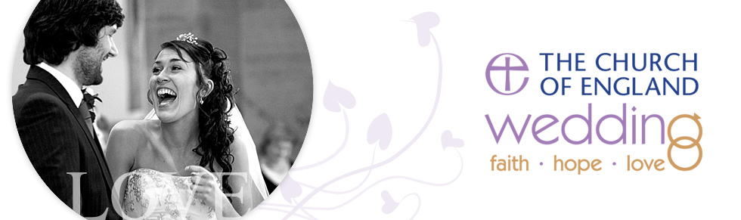

Church Office, c/o Church Gate Centre, Church Gate, Lutterworth, LE17 4AN
email: office@lutterworthchurch.org Web www.lutterworthchurch.org
Telephone: 01455 558797

